**1.Suppose you have a Piggie Bank with an initial amount of $50 and you have to add some more amount to it. Create a class 'AddAmount' with a data member named 'amount' with an initial value of $50. Now make two other derived class as follows:**

**Base class - no amount will be added to the Piggie Bank. Derived class - having a parameter which is the amount that will be added to the Piggie Bank. Create an object of the 'AddAmount' class and display the final amount in the Piggie Bank.**

import java.util.*;

import java.io.*;

class addamount{

int amt=50;

void disp(){

System.out.println("Amount in piggy bank: "+amt);

}}

class base extends addamount{

void disp1(){

System.out.println("No amount is added");

}}

class derived extends base{

void disp2(int x){

amt+=x;

System.out.println("Amount in piggy bank: "+amt);

}}

class piggy{

public static void main(String[] args){

derived d=new derived();

d.disp();

d.disp1();

d.disp2(500);

}}

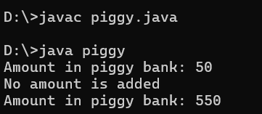

**2. Write a JAVA program to demonstrate the multilevel inheritance by creating a class cuboid which extends class rectangle, class shape. It calculates area and volume.**

import java.util.*;

import java.io.*;

class cuboid{

void calc(int x, int y, int z){

int sa=(2*x*y)+(2*y*z)+(2*x*z);

System.out.println("Area of cuboid: "+ sa);

System.out.println("Volume of cuboid: "+ x*y*z);

}}

class rect extends cuboid{

void calc1(int x,int y, int z){

System.out.println("Area of rectangle: "+ x*y);

System.out.println("Volume of rectangle: "+ x*y*z);

}}

class shape extends rect{

void calc2(){

System.out.println("The above shapes are: cuboid and rectangle");

}}

class multishape{

public static void main(String[] args){

shape s=new shape();

s.calc(2,5,10);

s.calc1(2,3,10);

s.calc2();

}}

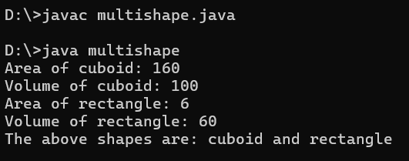

**3. Write a program to calculate the bonus of the employees. The class master derives the information from both admin and from account classes which derives information from the class person. Create base and all derived classes having same member functions and parameters called getdata, display data and bonus.**

import java.util.*;

import java.io.*;

class person{

String name;

int age;

void getdata() {

Scanner sc = new Scanner(System.in);

System.out.print("Enter name: ");

name = sc.nextLine();

System.out.print("Enter age: ");

age = sc.nextInt();

}

void displaydata() {

System.out.println("Name: " + name);

System.out.println("Age: " + age);

}

void bonus() {

System.out.println("Bonus:0.00");

}}

class admin extends person {

double salary;

void getdata() {

super.getdata();

Scanner sc = new Scanner(System.in);

System.out.print("Enter salary: ");

salary = sc.nextDouble();

}

void displaydata() {

super.displaydata();

System.out.println("Salary: " + salary);

}

void bonus() {

System.out.println("Bonus:" +salary * 0.10);

}}

class account extends person {

double accountsManaged;

void getdata() {

super.getdata();

Scanner sc = new Scanner(System.in);

System.out.print("Enter number of accounts managed: ");

accountsManaged = sc.nextDouble();

}

void displaydata() {

super.displaydata();

System.out.println("Accounts Managed: " + accountsManaged);

}

void bonus() {

System.out.println("Bonus:" +accountsManaged * 50);

}}

class master extends admin {

double accountsManaged;

public void getdata() {

super.getdata();

Scanner sc = new Scanner(System.in);

System.out.print("Enter number of accounts managed: ");

accountsManaged = sc.nextDouble();

}

void displaydata() {

super.displaydata();

System.out.println("Accounts Managed: " + accountsManaged);

}

void bonus() {

System.out.println("Bonus:" +(salary*0.10 + accountsManaged * 50));

}}

class hard {

public static void main(String[] args) {

master m = new master();

m.getdata();

m.displaydata();

m.bonus();

}

}

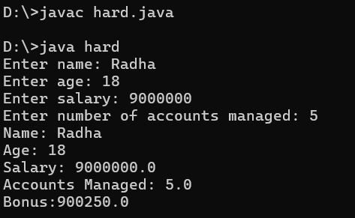

**4. A paper consists of 4 authors, but one author didn’t do any work but he wants to put his name in this paper. But others are not interested at the same time they want to add another author as a 5th author. How to identify the Not worked for paper. Write a Java code for the above scenario.**

import java.util.*;

import java.io.*;

class author{

String name;

String contributed;

void getname(){

Scanner sc= new Scanner(System.in);

System.out.println("Enter author name:");

name=sc.nextLine();

System.out.println("Enter if" +name+ "has contributed: (y/n)");

contributed=sc.nextLine();

}}

class paper extends author{

void disp(){

if(contributed.equals("y")){

System.out.println("\nAuthor has contributed:"+name);

}

else{

System.out.println("\nAuthor has not contributed:"+name);

}

}}

class book{

public static void main(String[] args){

paper p=new paper();

p.getname();

p.disp();

p.getname();

p.disp();

p.getname();

p.disp();

p.getname();

p.disp();

p.getname();

p.disp();

}}

